Halaqa: Wednesday, April 30, 2014
Topic: Responsibility towards parents (2)

066.006

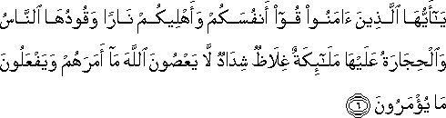

“O you who have believed, protect yourselves and your families from a Fire whose fuel is people and stones…”

Reminder 1: Firmly ground yourself in matters of belief
- “O you have who believed’
- Act and educate yourself in matters of belief

Reminder 2: I am responsible for my own belief matters before anyone else
- ‘protect yourselves’

The fuel of fire are people and stones
- If we do not believe, we will be the fuel of fire with our disbelieving thoughts (which is the result of a hardened heart)
- Stone: Alluding to something that is ‘dead’
  - Without belief, all of life’s experiences/interactions/objects are limited and possess no purposeful meaning in relevance to my existence. The disconnect and meaningless are all components of hell
  - With belief, each interaction and action is performed with the consciousness of the Creator, transforming it from a limited scope into the Absolute realm (paradise)

Unless we protect ourselves first (in matters of belief), we cannot help our families.

031.013

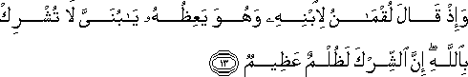

“And, when Luqman said to his son while he was instructing him, “O my son, do not associate [anything] with God. Indeed, association [with him] is great injustice.

The character of Luqman teaches us how to raise our children.
- The foundation of all advice begins with not associating anything with God
  - I will only able to give such advice if I myself do not associate anything with the Creator

Unfortunately, what is commonly observed in Muslim communities today:
- Enforcing rules and rituals
  - Pray
  - Fast
  - Bringing children to the mosque

We are being reminded, through Luqman (AS), that the fundamental teaching to our children needs to be about tawhid
- We have to direct attention and consciousness to the fact that there is no other Creator but Him
  - Practically, train children (and, of course, first ourselves) to see the Creator in everything

When we commit idolatry, we are disconnecting ourselves from the Creator and disconnecting ourselves from His forgiveness

‘God does not forgive idolatry’
- NB: Always read the Quran from your perspective (not God’s perspective)
- This means, that idolatry in its own nature does not deserve forgiveness
- Why?
  - Because, idolaters do not turn to God to repent since they are disconnecting themselves from Him
- As soon as idolaters reject idols and confirm God, they are automatically in His presence
  - Whoever turns to God (see His Creatorship in everything) is in His presence
  - Once we are in His presence, we are automatically forgiven

My task: To firmly establish tawhid (the oneness of God) with sound evidence that convinces me in my life
- That is the foundation of belief
- Only after I am firm in my belief, can I advise my children (and families)

Shirk: Explaining the existence of ANYTHING by referring it to itself (or to another created object)
- By committing shirk I am worshipping idols

A practical guide to checking one’s belief:
- Ask yourself: Am I interpreting things in this world as signs, pointing to the Creator, OR do I just see things for what they are?
- When we do not see objects as signs to the Creator, the objects are nothing but ‘stones’
  - Why?
  - Because, a limited, transient object has no meaning for my human desires which seek eternity
- We should be careful not to turn anything into a ‘stone’
  - How?
  - Train yourself to see beyond the objects by investigating the nature of existence so that you may see the qualities of the Creator in everything

All the objects in this universe are themselves ‘lifeless’ and ‘innocent’
- Everything only has meaning/life in as much as we connect them to their Creator

Analogy: Drinking water
- Drinking with consciousness (believer) means seeing the water as Created by the Absolute Creator
  - The thirst that is quenched is the result of my Creator’s Will because as I observe, the water has no power to do that
- Drinking without consciousness is like drinking ‘stone’
  - The water itself cannot satisfy your thirst
  - If you do not see the Creator of the water, you are disconnecting yourself from Him, an act which renders the water meaningless for your eternal desires
    - You drink the water and it’s gone
    - Yet your desires to be eternally satisfied remain unfulfilled

When we fail to see meaning in objects, we are turning them into meaningless stones.
- If it is meaningless, it is disconnected from the Creator
- If it is disconnected, it is in Hell

In the fire, I will find nothing but meaninglessness

031.014

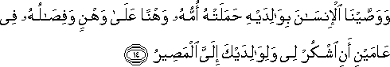

“We have enjoined upon man kindness towards his parents: his mother bore him by bearing strain upon strain, and his utter dependence on her lasted two years: Be grateful towards Me and towards your parents, [and remember that] with me is all journeys’ end.”

God acknowledges all the work that our mother has done for us BUT we are reminded to first be grateful towards the Creator because it is He who created her and made her as an intercessor of His qualities.
- How else can we explain the source of compassion and love in parents?
  - Where does the ‘maternal instinct’ come from?
  - Don’t shackle yourself with the limited/taken for granted language used by secularists and scientists

If I am grateful to God, I will automatically be grateful to my parents because I realize that my parents are signs in which God’s mercy is reflected.
- If I do not see the Mercy of the Creator of my parents in their role as parents, I will treat them as the source of mercy and worship them in response to the love I experience
- Always establish the Creator’s act first
  - If not, we will turn our parents into ‘idols’

Ilayyal masir: “At the end, everything comes to Me.” That is, God is the Last Destination.
- The kindness we feel to/from our parents should end with God
- Drinking water should end with God
- All our journeys should end with God

NB: This verse also reminds us of the methodology we should adopt when developing belief
- The Creator says: ‘at the END, everything comes to me’
- We have to first investigate the object and have that lead us to the Creator
  - By making declarations such as ‘God created everything’ without first confirming and experiencing it in reality, we cannot become convinced believers.

Our parents are only the means to transfer God’s qualities to us.

031.015

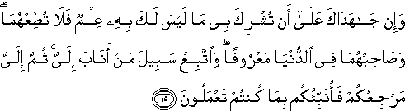
“And if they contend with you that you should associate with Me what you have no knowledge of, do not obey them, and keep company with them in this world kindly, and follow the way of him who turns to Me, then to Me is your return, then will I informed you of what you did.”

Treat parents kindly BUT when parents turn you away from the Source, do not obey them in that matter.
- We should follow the way of those who turn to the Creator
  - If our parents appropriate the qualities that the Creator has endowed them with, we should not agree with it
  - We have to acknowledge the Giver of their qualities
  - Always search for the SOURCE

Treat parents kindly BUT always remember that we will be accountable to the Creator.

When reading the Quran, always ask: ‘Why are you telling me this?’ “What is the message in this passage for my human qualities?"
- If we don’t position ourselves as the addressee of the Quran, we will be unable to obtain the guidance

031.016

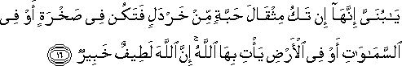

“O my dear son,” [continued Luqman,] “verily, if there be but the weight of a mustard-seed, and though it be [hidden] in a rock, or in the skies, or in the earth, God will bring it to light: for, behold, God is unfathomable [in His wisdom], all-aware.”

Through Luqman, we are being told: Teach children (and our families) to see the Creator in every, single, tiny detail
- When studying biology, see and realize that the qualities of a cell is BROUGHT and GIVEN by the Creator
- When studying physics, see and realize that all the ‘laws’ are GIVEN existence by the Creator
- Everything is subject to His Lordship

*Practical lesson on how to establish the oneness of God.

‘Ya’ti bi ha Allahu’: God brings it
- Nothing in this world exists, except that it is brought into existence by God
- We have to trace God’s qualities, ownership and creatorship in everything back to Him
  - Why?
- Because without connecting creation to its Eternal Creator, the objects become meaningless and their existence becomes unexplainable.
- We should never attribute the qualities in things to themselves

031.017

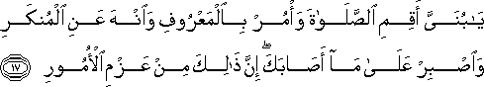

“My son, establish prayer, enjoin what is right, forbid what is wrong, and be patient over what befalls you. Indeed, [all that is of the matters] requiring determinations.
I should first ask: What is this verse telling to my human qualities?

The verse is saying: It is befitting my human qualities to establish my prayer
- Prayer: My submission to the Creator

I have to investigate and experience if this is true
- When I pray and submit to my Creator, I realize that my human qualities are at peace.

‘Enjoin what is right’
- ma’aruf: That which is known
- We have to make things ‘known’ for people and then present it to them
  - Without making something ‘known’ we should not command action because it goes against one’s human qualities to do something without ‘conviction’

Analogy: Prayer
- Don’t command someone to pray if they are not praying
  - That is not ‘ma’ruf
- Rather, make prayer known to the person
  - We ought to explain what prayer means and how it is beneficial for one’s human qualities
  - Once it is ‘known’, the person will automatically pray

‘Forbid what is wrong’
- munkar: That which should be rejected and is unacceptable
- We have to explain why it should be rejected

Analogy: Drinking alcohol
- Don’t stop a person from drinking alcohol
- Rather, make it obvious for the person that drinking alcohol should be rejected by explaining how it goes against our human qualities

31.018

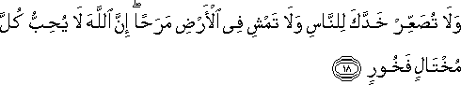

“And do not turn your face away from people in contempt, nor go about in the land exulting overmuch; surely God does not love any self-conceited boaster.”

We should treat people as equal beings
- If you think that you hold the truth, then present it
- There is no room for ‘exclusive communities’
  - Exclusivity stems from arrogance

Keeping company with the righteous means being companions with those who share the same worldview
- It does not mean ‘neglecting’ or leaving others out
- When we have ‘negative experiences’ we have to establish the righteous way of belief

Within my own self, I realize that I have to constantly discern between that which is ‘right’ and ‘wrong’
- I can be my most righteous companion if I constantly pay attention and choose that which is ‘right’
- ‘right’ = the way which turns me towards my Creator

031.019

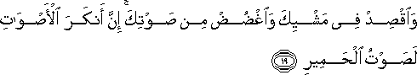

“And be moderate in your walk, and tone down your voice; surely the most repugnant of voices is indeed that of the assess/donkey.”

The summary of the Chapter Luqman (31): 13-19

- Not to ascribe divine powers to anything other than God
- To be good and kind to parents
- Do not obey parents when they command what is wrong
- To understand that all our deeds, however minor, are recorded and will be brought to light
- To be constant in prayer
- To enjoin what is right and forbid what is wrong
- To bear what befalls you with patience
- To avoid pride, arrogance and boastfulness
- To be modest in manner and speech.

029.008

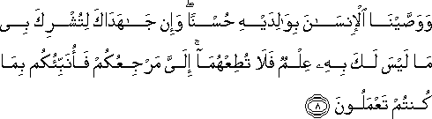

“We have enjoined upon man kindness towards his parents; yet, if they endeavor to make your ascribe divinity, side by side with Me, to something which your mind cannot accept, obey them not: [for] it is unto Me that you all must return and I shall tell you what you were doing.”

If parents claim that their kindness and compassion originates from themselves, it is a manner of ascribing divinity
- We are reminded that we should not subscribe and accept it

Parent says: The world comes first. Do not worry about religion.
- Quran says: Do not obey them because it is unto Him that we will all return
- We have to ALWAYS give God priority because He is our Creator and Giver of everything

We should prepare our children to worship God, through the emotions given to us
- Do not ascribe the love you experience from your mother to her BUT recognize that it has been given to her
- We have to train ourselves to not ascribe qualities to ourselves or to created things
- Always see the Source!

