Halaqa: Wednesday, December 4, 2013
Title: ?

What comes to mind when you think of the word ‘strawberries’?
- Something to eat
- Ice cream
- Fruits
- Juice
- Color
- Attractive

The perfection and interplay of textures/colors reflects artistry.
The artistry itself reflects something beyond the art and points to the artist.

When you observe the physical fruit, it stimulates senses and you are reminded of how the fruit tastes.

“We may look, but we may not see”

Although we encounter the physical strawberry or interact with a script, we have to move beyond just seeing the things as they are. We have to train ourselves to look at these objects and see what they are pointing to.

“And how many Signs in the heavens and the earth do they pass by? Yet they turn (their faces) away from them!”
Yusuf (12): 105

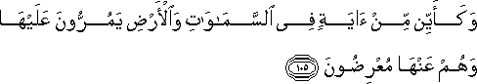

All of creation is a sign.
- We have to look at creation with a critical eye
- This whole world consists of nothing but signs
  - From the written word, to the physical objects, everything is a sign that points to the qualities of its Creator

In this verse, God reminds us that everything is a sign but we turn our faces away and choose to not see them as sign.
- We chose to restrict ourselves to the physical definition of the things themselves and in doing so, fail to truly acknowledge the purpose of creation

The physical strawberry itself has no meaning. Once you eat it, it is gone.
- You have to take notice of the sign
- If you don’t take notice of the sign, you are not using your human qualities

“And most of them do not even believe in God without [also] ascribing divine powers to other beings beside Him.”
Yusuf (12): 106

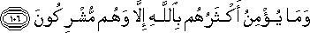

You may not be worshipping an idol BUT as long as you don’t read ALL the signs as pointing you towards the qualities of God, you are a mushrik

The Quran says: If you don’t take notice of the signs around you (even if you believe in the Creator), you cannot save yourself from falling into shirk (ascribing powers to others beside their Creator)

That means we have to see all signs in the world as pointing us to the qualities of the creator and not as objects in and of themselves.

When we see a strawberry, we should be seeing:
- Mercy
- Benevolence
- Sustenance
- Perfection
- Beauty
- Wisdom

If you don’t see these qualities or refer its physical qualities (beauty, color, taste) to the Creator, you have just ascribed the qualities in the strawberry to itself, and in that committed shirk.

The One who prepared the strawberry, is referring me to His qualities.

This verse is inviting us to look at all of creation and to ascribe the qualities we see in them to its real Source
- If you don’t question about the source in all of creation, you will end up ascribing the qualities of the object to itself (unintentionally)

We are being guided in this verse, that shirk creeps in when we don’t see the SIGN in creation and sub-consciously refer to the object as being just the object WITHOUT seeing God’s compassion and mercy.

“Turn their faces away from them” – You consciously turn your face away from the message it brings to you.
- Some people deliberately chose not to see the sign (they know it points to God but chose to not see it)
- Others may not do it deliberately BUT are over-focused on the object itself and hence do not see the sign in it.

These verses are guiding you and reminding you to NOT turn away from the signs.
- If you don’t heed the reminder you will be falling into shirk
- And we know how shirk is a major sin

We are being reminded to not be led away by that which is apparent BUT to look for the sign in all of creation.
- The Quran is calling us to pay attention to the message we receive from the object
- Otherwise, you are falling into shirk

Falling into shirk is not a deliberate action (in most cases)
- Inconspicuous (Ash-Shirk ul-Khafie )(you don’t mean to ascribe any divine power to things beside God, but you do it)
  - Hadith: "Ash-Shirk ul-Khafie in the Muslim nation is more inconspicuous than the creeping of a black ant on a black stone in the darkness of the night."

You are either turning to consciousness OR turning away from consciousness
- Foundation: The Quran is a guide for those that are CONSCIOUS
- How are you using your consciousness?
  - Do you use your consciousness to read the message inscribed in all of creation
OR
  - Are you turning away from your consciousness and leave the qualities within the object themselves instead of attributing them to their creator.
    - Hidden shirk: leaving the qualities within the objects themselves

Hadith: What I fear for my ummah, more than the Dajjal, is hidden shirk
- Dajjal – Anything that attempts to eradicate religion

“Do you not see how God has created seven heavens in harmony, and has made the moon a light therein, and made the sun a lamp?”
Nuh (71): 15-16

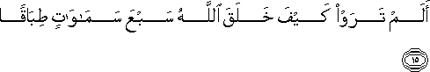

Moon as a light – The moon has deliberately been made to function as a source of light in the night

Sun as a lamp – The sun has been purposefully created to provide you with light

We have to look at the moon and the sun with a critical eye so that we may see the qualities of God (perfection, wisdom, balance, beauty, mercy, etc)

Methodology: The Quran invites you and asks you to see
- It does not merely command you to believe!

I have to investigate HOW things come in existence

NOT

Why things are coming into existence
- The question ‘why’ is irrelevant
- I cannot speculate on God
- No one can answer the ‘why’ questions

When I look at the universe, I can see that it is bringing me a message
- I have to investigate to be able to read the message in creation

Pitfall: Scientists tend to push religion into the realm of ‘why’ and hence conclude it is irrelevant
- They then claim that science answers how
- But in reality, religion answers the questions of ‘how’ must coherently
- From ‘how’ I will inevitably be led to ask ‘where’ the things are coming from
  - If I can find a source in this world, then so be it
    - But my investigations prove that NOTHING in this world can create anything
    - There must be a creator

Some common-day answers to the ‘how’ question
- Everything is an accident
  - If everything is happening by accident, there is no point of studying
  - Science exists to find the order in creation
  - If there is order, it cannot be an accident
- Nature
  - To ascribe the existence of nature to nature is circular
  - How can nature make nature?
We have to investigate how things are coming into existence so that we may arrive at a confirmed answer
- Everything comes into existence by a conscious will

Science is simply about studying nature and all of creation (the order, the qualities, etc)
- Science studies ‘how’ but ascribes the qualities to non-rational/non-founded sources
- This is because scientists are desperate to prove that the Source is within this universe
- However, this makes no sense
  - They end up with circular reasoning
- The Source of the qualities we observe is the Source of everything
  - Since everything is coming in a perfect manner, He must be Absolute
  - If He is Absolute, He cannot exists as part of this universe

Everybody is studying ‘how’
- No one can study ‘why’
- Don’t fall into what the scientists label religion (the study of ‘why’)
  - This is because no one can study why
  - By labeling religion as the study of ‘why’, science is setting religion up to be a farce

By studying how the earth is functioning, I understand that the One who made it, deliberately gave it these specific qualities

This is why the Quran always uses the word kaifa (how) NOT why

We cannot base our belief in God on speculation
- Reclaim the fact that religion is about studying ‘how’ the universe came to be and investigating it
- Don’t get lost in imitation

All the qualities in creation point to the Creator
- You will not find a single crack in the entire universe
- Everything is perfect
- This perfection belong to the qualities of the Creator (God’s perfect names)

This is an important duty that we have to fulfill
- Study how the heavens came into existence
- And see the Creator

Methodology: In everything that you interact, look at HOW it is coming into existence and see the SOURCE

Don’t read the Quran as stories.
- The Quran is a guide
- It is telling us to look at the moon/sky/sun
- It is not just telling us a story about the moon/sky/sun
  - We have to practice this religion by investigation

“Do you not see that before God prostrate themselves all tat are in the heavens and all that are on earth, the sun, and the moon, and the stars, and the mountains, and the trees, and the beasts? And many human beings…”
Hajj (22): 18

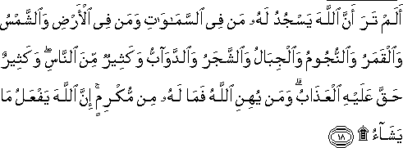

See how Allah presents the narration – from macro to micro
Heavens
All that are on earth
The sun
The moon
The stars
The mountains
The trees
The beasts (daa’ba: anything that moves)
- As science progress, we see how there is NOTHING in this world that does not move
- So while the translation says beasts, the literal translation is actually anything that moves.

Prostration: Submission
- I am speechless before what I see
- I have no claim
- I am zero
  - Not only humans BUT everything (moon, stars, trees) ALL acknowledge that they have no claim and that all the qualities they posses belong to the Creator

We, conscious beings, have to investigate who the qualities belong to (since submission means acknowledging/declaring that they have no claim over all they possess)

When we prostrate, we have to be aware that EVERYTHING in this universe is prostrating but only SOME humans prostrate.
- Every single particle prostrates
- But some humans (consciousness) claim to be the owner of their own qualities are do not prostrate

In your day-to-day activities (beyond the prayers), we have to be conscious that
- We are one with all of creation and that we are ALL created with no claim over anything
- I acknowledge that He is the owner of everything
- Only then does your ‘physical submission’ have any value

There is no tradition in Islamic scholarship that emphasizes on how we should read the Quran
- We have to establish our foundations
  - Quran is the speech of the Creator to teach me how I should evaluate my life so that I may reach a certain conclusion
  - We have to see that everything is submitting to the Creator (and not seeing anything as belonging to themselves)
    - The Quran is speaking to YOU (conscious human beings) and guiding me as to how I should understand the activities of all of creation

Have you seen any creature (apart from some human beings) disobeying their Creator?

Have you seen any creature receiving the qualities of their Creator AND not reflecting it?
- Nothing in this world absorbs the ‘ownership’ of the quality
- Everything intercedes between me and my creator
  - Nothing ‘absorbs’ the qualities within themselves
  - They all reflect their qualities to the Creator

“Do you not see” – The Quran is calling us to see and investigate

“Do you not see that it is God whose limitless glory all [creatures] that are in the heavens and on earth extol, even the birds as they spread out their wings? Each [of them] knows indeed how to pray unto Him and to glorify Him; and God has full knowledge of all that they do.”
Nur (24) : 41

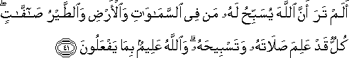

Everything EXTOLS his glory
- The birds know how to pray (salah)
  - They are obeying the order that they have received in creation
  - Salah = obey/submit glorify
- Ask yourself: What is my prayer that is intrinsic to me?
- Everything in creation knows that it is doing
  - Are we aware of what we are doing?

We have been given the freedom of will to choose how we will use our consciousness.
- We have to see that everything is performing its duty
- Ask yourself: Are you using your qualities as per what is expected from you?

“Do you not see that God has sent down rain from the sky and the earth becomes green? Indeed, God is ever-kind, ever-cognizant.”
Hajj (22): 63

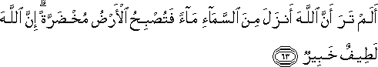

The fundamental aspect of religion is to SEE the Creator in everything, even when it rains.

“Do you not see that God has subjected to you whatever is in the heavens and whatever is in the earth, and He has conferred upon you His favors, both outward and inward…”
Luqman (31):20
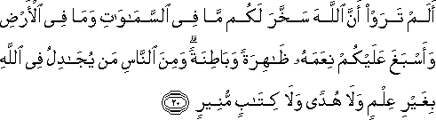

Everything is a means for us to receive God’s favor (both in its outward and inward form)
- Zahir (outward): The light from the sun is a favor in that we need physically
- Batin (inward): The light is also a favor to you inwardly. It provides you with security. He takes care of you.

“Do you not see that God merges night into day and He merges day into night; that He has subjected the sun, and the moon (to you), each running its course for a term appointed; and that God is well-acquainted with all that you do?”
Luqman (31) : 29

031.029

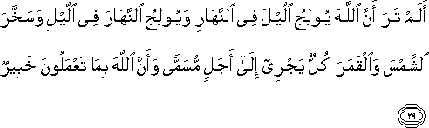

We have to SEE the order in creation
- God is reminding us in the Quran to do so

“Do you not see that God sends down water from the cloud, then makes it go along in the earth in springs, then brings forth therewith herbage of various colors, then it withers so that you see it becoming yellow, then, in the end He causes it to crumble to? Indeed, there is a reminder in this for the men of understanding. Zumar (39): 21

