Date | Wednesday, October 28 2015
Topic | In the footsteps of the Prophet Abraham
Part | 11
Prophet Abraham’s main concern was to escape from falling into shirk. He was looking for the source of existence of matter. When he realized that any matter cannot sustain its own existence, they are dependent themselves, he sets himself searching for the One that sustains everything.
What is “shirk”?
- Ascribing deity quality to matter or created being.
- Example 1: Without an object/matter/person, I cannot survive.
- Attributing divine qualities to matter itself. Mostly “divine” is defined as the One who creates the universe. Although, I may be aware of divine presence in my life, ascribing any quality to the constituent parts of any order, a rather small area is still “shirk”.
- Example 2: I need oxygen to breathe. I know that oxygen is created by its Creator. If I think oxygen air is contributing to my existence, that is shirk.
- Attributing any action/object as the Source of existence of another object is similar to attributing divine qualities to that action/object.
- If a thing cannot give existence to the universe, it cannot be the Source of existence of anything else.
- I cannot survive without oxygen. Yes, that is correct. But this statement should not be taking to mean that oxygen is contributing to my existence, rather, my existence has been given by the One who creates this universe with a certain order and this order includes my existence alongside with oxygen.
With example 1, Ask: Which qualities do I attach to a specific individual? Does the object/matter/person have the power to create anything, let alone the universe? No. A particle cannot be the Creator of its own existence.
- Example 3: A building is made of bricks. If I remove the bricks from one side, the building will collapse. Ask: Are the bricks sustaining the building? Although, it is true that without the bricks, the building cannot be sustained but it should not mean that I ascribe divine qualities to the brick. The bricks have been employed to hold the building. This is the order in creating the building with bricks.
Common rhetoric: A cell reproduces itself. It means that the cell is responsible for creating the reproductive action.
- Ask: Can the cell give existence to itself? Is the quality to reproduce within the cell the product of the cell itself? Is it coming into existence by itself? No, the cell is employed to reproduce. This is the order of creation.
- If I cannot give existence to my life, I cannot give life to my child. My life must be dependent on the Creator of the universe, i.e. an Absolute Source.
Common rhetoric: Gravity pulls objects in the universe. Here, an action is attributed to another thing which itself needs to sustain its existence by something else (Cause/Source). Following the line of reasoning above, I should realize that gravity is not the Cause of pulling me. “Gravity” is nothing but a part of the order.
With that realization, we can understand how one may fall into committing “shirk”: by attributing divine qualities to the things themselves. The generic statements on Christianity falling into shirk by claiming that Jesus (pbuh) is the incarnate god is not the main reason. It is the fact of attributing the miracles performed by Jesus to Jesus (pbuh) himself. With the same reasoning, any miracles performed by other Prophets cannot be attributed to those Prophets themselves. Therefore, we should be vigilant not to attribute deity qualities to anything else except the Creator of the universe. We need to revisit our comprehension of various concepts and be aware of politically motivated general statements/accusations related to religious titles. The focus should be on whether we are good in our understanding of the matter.
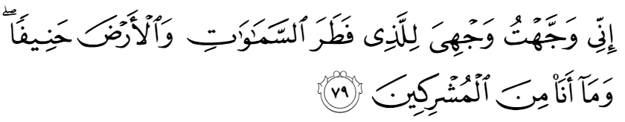
“Behold, unto Him who brought into being the heavens and the earth have I turned my face, having turned away from all that is false; and I am not of those who ascribe divinity to aught besides Him.” An’am (6):79
- Whoever brought the heaven and the earth into existence do I turn my face to, i.e. I am with Him, look to Him.
- False= matter creates the heavens and the earth. I turn my face away from all false.
- After realizing that any particle cannot be the Source of existence of another thing because it itself cannot create the universe, I conclude that the particle cannot be the source of existence and thus turn to the true Source.
Sinning is the worry for most human beings as opposed to committing shirk. We need to realize that it is not sinning that results in “shirk,” but the source of sinning may be “shirk.” We tend to think that we do not commit shirk as long as we pray and believe in God. Shirk may not be deliberately intended, but we have to be watchful since it is the act that is said to be unforgivable. The Quran does not even specifically say denial of God is unforgivable but “shirk” is. Why unforgivable? For example, if I claim to own the movement of my hand while typing for instance is an obvious error. When I unconsciously claim this movement or attribute it to my muscles, brain or cells, I am insulting the true creator of this movement, although I am aware that my hands, muscles and brain etc. are given to me. Again, I should ask can my muscles or cells be the creator of the universe. If I do not confirm the Creator and attribute all what He created to Him, there is always a possibility that I may ask Him to forgive me. Once I admit that He is the Creator and ask for forgiveness for my mistakes, then I will be forgiven as God Himself promises. A person in the state of “shirk ” does not acknowledge that He is doing something wrong.
The scripture gives a warning by telling us that you claim to believe in God but at the same time you say that the movement is from the muscles or cells. I may not intend it but may be attributing divinity to the muscles/cells or any created thing. The scripture guides me to realize that all these abilities are given to me and I am just using them. Rather than giving importance to sinning (forgivable), I should give priority to staying away from shirk.
- Sinning= not being consistent in acknowledging my realitydenying God.
- The problem does not lie in sinning, it lies in the weakness of my belief in a Creator, which is polluted by shirk. That’s why I am not consistent within myself.
When one sins, one is aware that they made a mistake. Being concerned is good and an opportunity to turn to God and seek forgiveness. However, with shirk, false god is not God and thus it is not possible to turn to God at that moment.
Scripture draws our attention to shirk: If you cut off the roots of shirk, you will not sin. Alas, I have dispersed my focus everywhere (i.e. attaching values to societal norms, objects…); therefore I cannot keep my consistency in having “one object of worship”. Only by “freeing” myself form attaching value to other created beings/objects can I be on the path to belief.
A weak belief in God, the Creator has strong consequences. Prophet Jesus alarmed people not to be “fools”.
- Fool= not being aware of committing shirk which results in sinning.
- Sinning is only a symptom. Cure for sinning is not committing shirk i.e. being aware of the fact that any created thing cannot be the creator of anything else. That is your belief.
Shirk lies in how we view objects/events in the universe including our understanding of atoms and particles. How do we see the activity and motion of particles?
- Ask: Are the particles moving or is it a new creation?
We think earth is moving but it does not move; it is made to move as part of the order in creation. Order of the universe is mostly mistaken by the people as: the universe itself is moving. There is no gravity and motion in the universe; everything seems to be in continuous motion i.e. it is in continuous creation. Continuation appears to us as “time”.
The order of renewal takes on a certain form which I know from previous experience: I am not getting older; I am being renewed into a new form which is part of the created order. If I am created tomorrow, I (my creation) will be renewed.
If you are careful, just like Abraham, you will attach your existence to the One that brought into being the heavens and the earth.
Lord= the One who brought the universe and my being into existence. I cannot survive without my Lord, neither can the objects.
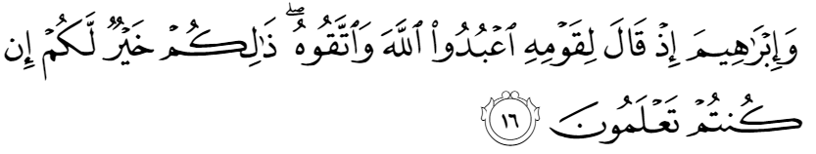
“And Abraham, as he said unto his people: “Worship God, and be conscious of Him: this is the best for you, if you but knew it!” Ankabut (29):16
- Abraham establishes the qualities of God within himself, i.e. to give the description first before using the title of “God”.
- He recommends everyone else to worship the One who has the power to create, the Creator.
- Give the reasoning first and then put the title: The One who is the Creator is “God”. The One who puts the universe intact is “God”.
- Before coming to a conclusion, always find out if an object/matter can be the Creator i.e. has the power to create and produce.
- The constituents of the order do not bring anything into existence.
- Ask: Is the sunrise causing the day break or is the sun created by its Creator to cause daybreak to appear in a new form of creation?
- We are created in the order to follow the order. The order is established by my Creator. By obeying the order, I am obeying the Creator of the order.
- This needs the awareness of what I believe in i.e. while following the order, I must be conscious that I am obeying the order.
- Example: I go to the doctor knowing that the doctor is knowledgeable in helping me follow the order. I do not go to the doctor thinking that he is the Source of my cure.
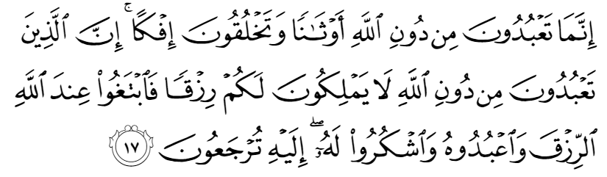
“You worship only man-made deities instead of God, and you create a lie! Behold, those that you worship instead of God have it not in their own power to provide sustenance for you: seek, then, all [your] sustenance from God, and worship Him [alone] and be grateful to Him: [for] unto Him you shall be brought back!” Ankabut (29):17
- I cannot worship something that does not sustain my life.
- Creation Creator.
- Whoever gives existence to the universe is your Creator; you will be brought back to Him: your gratitude must be returned back to Him.
- Instead of saying: I cannot survive without the act of creation of the heavens and the earth, say: I cannot survive without the Creator of the act of creation in the universe.
- I may be sinning because of my lack of understanding of the universe and uncertainty in my belief in the Creator. I may say: the particle is emitting light.
- Ask: Is the particle giving existence to the universe?
- Again, a particle cannot give existence to another particle, it itself needs to be created.
In conclusion, the universe must have a Creator. We should learn from prophet Abraham of being aware of not ascribing deity qualities to anything in the universe but the Creator of the universe.

