Wednesday, March 25, 2015
Topic: “Remembering God” (part 2)
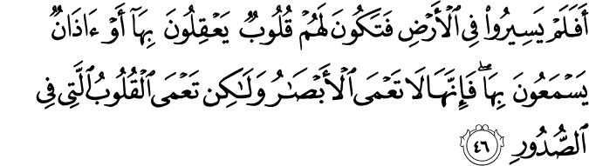
“So have they not traveled through the earth and have hearts by which to reason and ears by which to hear? For indeed, it is not eyes that are blinded, but blinded are the hearts which are within the breasts.” Hajj (22):46
This verse seems to be jumping from what is conventionally understood to what is hidden within the text: Traveling through the earth HeartReasoningEarsEyes
- “Traveling through the earth” means to pay attention to creation around us.
- Example: A dentist studies the structure of a tooth and questions:
- Are the cells producing by themselves?
- We need to refer the findings to our own existence.
- We cannot ignore the universe.
Quran encourages the reader to reason with the heart. We cannot really separate the power to reason (intellect) from the power to feel (emotional side). Human senses are given to us in order to “reason”. Unfortunately, we are mostly trained to think rationally without having our emotions interfere with our reasoning. Similarly, when we use pure emotions, we are listening to our intuitions only.
- Feel the objects around you, collect the data and analyze it. Now internalize all this i.e. combine your heart with your human senses.
- We need to reason with our “feelings” and “intellect” altogether. They go back and forth together i.e. sometimes our emotions come first and we need to use our intellect accordingly and vice versa.
- The revelation teaches us that which we do not know.
How can we confirm that revelation teaches us what we do not know?
Every text has different meanings according to the attitude of its reader. We come to a conclusion after reading the text; that is the only way we become aware of something.
- If the scripture did not tell me what I need to know, I will never be able to confirm the Absolute (ghaib).
- Example: I observe a flower growing. I question how it is coming into existence. The growth of the flower looks magical. Yes, it grows within a certain “order” but it does not mean that the elements of the order are the real cause to bring the result into existence. I am left with a great bewilderment.
- I cannot find the answer in the universe and so I benefit from the scripture as to get guidance from it.
- As a result, I conclude that there must be “something” not subject to time-space giving existence to every constituent elements of the flower.
- That is why the Messengers came with miracles in order to draw our attention to their message and not to the miracle itself. We do not believe in the Prophets because they performed miracles, rather we believe in the Prophets as being the Messenger of the Creator because the message they come with makes sense to us. They demonstrated to us that the Creator responds back. We check: Is it really true what this Messenger says?
What is the purpose of the Quran when it tells us: hearing is a tool given to us to hear or eyes are given to us to see?
- The fundamental matter that the Quran asks us to contemplate on is the “existence of everything”.
- Example: A car runs over a cat. You are terrified because there is blood everywhere.
- ASK: How can I explain the existence of the feelings? How can I explain the existence of this event?
One should always go to the Source of the matter. Always pay attention to the existence of the objects/events. Question the Source of existence of the feelings. When a baby grows, we attribute the baby’s growth to the renewal of the cells. ASK: How does “renewal” exist? Who is taking care of this action?
Materialist scientists always question the “sequence of the order” in the existence; they never question “existence”. If we do ask about the qualities of every object/event that we observe in the universe, we will not be carried away with the sequence of the order. Example: a flower grows under sunlight, air and water. We need to reflect on the existence of each entity, its qualities and processes. In this way we will not fall into the trap of attributing deity qualities to the entities/processes.
- When someone takes existence for granted, he/she easily falls into explaining creation within the sequence of order i.e. a causal chain.
The ability to use all of our senses and analyzing what we observe is within us, that is our reality. If something attracts our attention, we need to question its “existence”. When we question, we open a window to confirm our reality and we reason that there must be a Source of existence behind every event. This Source of existence is demonstrating His qualities to us, making His existence apparent to us.
- Through the qualities that we observe in this universe, we understand that these qualities are from Him.
- We get to know Him by looking at His work.
Our existence has nothing to do with rituals. Our existence has to do with the way that we observe the universe and how we regard ourselves before the Creator. Example: If someone does not fast to acknowledge the Creator (that HE is the Generous One, everything belongs to Him), then fasting gets reduced to hunger only. Only the consciousness/awareness (responding back, acknowledgment) makes fasting into an “act of worship”.
- When we fast, we express our awareness of God. In this sense, rituals are not reduced to physical activities only.
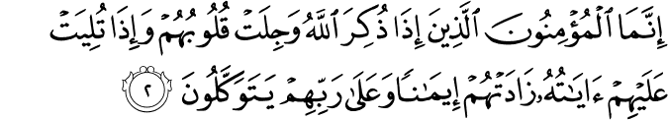
“Believers are only those whose hearts tremble with awe whenever God is mentioned, and whose faith is strengthened whenever His messages are conveyed unto them, and who in their Lord place their trust.” Anfal (8):2
- We need to establish some familiarity about the Creator manifesting Himself to us. We need to be convinced about Him being full of Compassion without any expectation.
- Analogy: If a close acquaintance dies, we feel in awe and we reminisce all the experiences we encountered with them.
- Similarly, we should feel the same way about the Creator at all times.
- Every time that we interact with the universe, we should be in awe with His manifestations.
- What does the Creator expect from us in return for the infinite Compassion, Mercy and Love He shows us?
- We need to acknowledge Him at every moment. If we do not acknowledge Him, we contradict our reality.

- The Creator does not harm anyone; we harm ourselves by not listening to our senses. He has given us senses that make us aware if we are doing something against our innate state (fitraa).
- We harm ourselves by not responding to the Creator.
- When we do not acknowledge Him or we are static in our acknowledgement of Him, He gives us an interruption in our routine.
- If we do not acknowledge the Source of our existence, then we feel unhappy with this interruption.

- When we chose something against our nature, we misuse our freewill. In other words, we deny our freedom to choose that which is “in tune” with our nature.
- Freedom comes first before believing in God or denying His existence. Freedom in terms of having an unbiased mind, free from inherited cultural concepts about reality i.e. belief or denial. To attain that, a person needs to detoxify himself from societal influence.
- We are created as conscious beings and so we ought to use our senses.
- Every news in the Quran needs to be confirmed right now.
- Belief is confirmation of our conclusions on our observations of the events happening around us.
(To be continued…)

