Wednesday, March 11, 2015
Topic: How to attain a “’satisfied heart”? (part 10)
In order to attain God consciousness/awareness (taqwa) which is necessary to attain a satisfied heart, we need to increase our confidence level in our belief. Awareness of one’s belief does not occur suddenly, it needs training, education and reflection. We can only obtain certainty about our belief by observing and experiencing the universe. Belief is certainty of your own conclusion. We cannot blindly follow a concept; even the Creator encourages us to observe His act of creation that He presents to us in this universe.
If we do not take this creation as a fundamental part of our religious life, we are bound to be imitators. We should give equal weight to both scripture and the universe. The scripture goes hand in hand with the universe; otherwise our existence will be meaningless. THINK: How can we believe in God without taking notice of His act of creation where He discloses Himself to us?
The message we receive from the universe is as sacred as the message received through the scripture. Scripture is the verbal Speech of the Creator and the universe is His act of creation. We are free to accept/deny the message. Religious scholars mostly emphasize on interpreting the text without taking the universe into account. We cannot ignore the universe i.e. the act of creation. THINK: If you are not searching for the Creator of the universe, what are you looking for and where are you going to find the concept o God if you have no inquiry about Him? Even if we receive the news through the revelation, it would mean nothing to us, since we are not looking for an answer to our question. The fact that the universe exists out there and the fact that we are questioning the source of existence of this universe, including ourselves in it, only then does the news of the scripture makes sense to us.

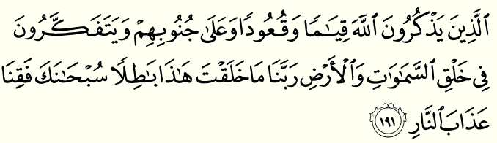
“Those who remember God standing and sitting and lying on their sides and reflect on the creation of the heavens and the earth: Our Lord! You have not created this without meaning and purpose! Glory be to You; save us then from the chastisement of the fire.” Al-Imran (3): 191
This is a simple verse to understand but we do not pay attention to the message in it. We need to reflect on creation and we need to remember the Creator at every moment.
- Explain your existence in terms of the Creator at every moment.
- How are the things coming into existence? (khalq’us- samawat wa’l-ard).
- Example: Reflect on the color of your eyes, it has been created and given existence.
Just claiming that God creates the eye color is running away from our responsibility; our responsibility is to reflect on creation. Reflection/contemplation is the most difficult thing to do but staying busy with other activities is easier. The Creator says: “Reflect on creation and see how things are created?”
- We need to train ourselves on how to reflect on creation for longer period of time.
- Example: The flower is beautiful. The flower makes you happy.
- Did you ever wonder about the Source of existence of beauty or any other quality in creation?
- How does you excitement comes into being?
Nothing comes into existence without purpose. Everything comes into existence deliberately by a Conscious Will. Example: when you observe an insect moving, is the insect coming into existence by itself? No. There is no real cause for anything to come into existence in this universe. Reflection of creation, as encouraged by the scripture is becoming more and more challenging because we are separating the discipline of secular sciences and philosophy. Science is mostly descriptive; not very analytical as far as the source of existence of the objects it studies. Besides, it only categorizes objects. Philosophy does not really go beyond the universe because of the impact of secular sciences on it.
Nevertheless, the Purpose of the Quran is to guide us and the Quranic message prompts us to ask: How are we coming into existence?
- Quran challenges us to pay attention to creation in this universe as it carries meaning. As per the verse, we are expected to come to this conclusion: “O our Lord, You have not created this (Heavens and Earth) without meaning and purpose!”
- Heavens and Earth: everything in creation.
- Khalq: creation, the things’ coming into existence.
- Subhan: perfect, free from any default.
- Whatever we “glorify” is free from defect.

- Ask yourself: What is the Source of the existence of my abilities?
- If your friend is speaking to you, reflect on: How is her speech coming into existence? How is your understanding of her speech coming into existence? How can two different entities communicate with each other? Can the matter employed in this creation be the source of the existence of these phenomena?
- Our responsibility is to take notice of the act of creation:
you are hungryyou eat foodreflect on creationconclude a Creator.
- If there was no creation, for us there would be no way to speak of the Creator; similarly, if there was no Creator, there would be no creation either.
- We need to take and reflect on existence in its entirety.

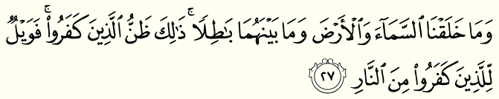
“And We did not create the heaven and the earth and that between them without meaning and purpose. That is the assumption of those who disbelieve so woe to those who disbelieve from the Fire”. Sad (38):27
If you want to really understand the reality and make your own being meaningful you have to study the universe. Only then can you find everything meaningful. When we read the Quran, the Speaker is speaking to us and says: “Go investigate and find the truth to what I, the Creator, am telling you”.
- Not wanting to admit the truth is our own doing which may cause us pain. Only people who do not want to acknowledge the truth claim that objects are meaningless.
- The dramatic/threatening language of the Quran is to let us know the abilities that we have been created with and so it is an encouragement for us to use it and acknowledge the Source.
After coming to the conclusion that the Creator of some object is “perfect”, we verify that conclusion with what the Creator says in the scripture. This consistency is perfect as it makes us realize that there is nothing lacking in creation.
Everything in creation is purposeful. Quran speaks to human beings according to their level of understanding, so we can understand our purpose in this universe. If we do not direct ourselves to the truth, our life will be in “fire” i.e. our existence will be meaningless. We will suffer from burn i.e. no purpose in our existence. On the other hand, if we confirm the truth and submit to the fact that His existence is perfect, “fire” (i.e. meaninglessness) will not come to us or consume us.

