Date | Wednesday, May 13, 2015
Topic | How to be Happy?
Part | 2

In order to understand scripture, we need to understand the nature of the Scripture i.e. the word of God. Scriptures needs to be read in a particular way. The Creator helps us by guiding us through His speech. Ultimately, we have to help ourselves from the guidance that we get from the scriptures. We help ourselves by using our human qualities, reasoning and come to a conclusion. We need to read scriptures to confirm the meaning from a message which could be a consequence of what we may face as a result of not being responsible towards our existence.
- Our responsibility is to accept creation as it is by always acknowledging the Source.
What happens if we do not remember God? If we do not ascribe creation to its Creator, then we reduce our existence to this life only. Any event which is not ascribed to a conscious Creator will end up in a dead end.
- We need to relate every moment to its Source in order to get pleasure from our existence. If pleasure disappears, life gets gloomy.
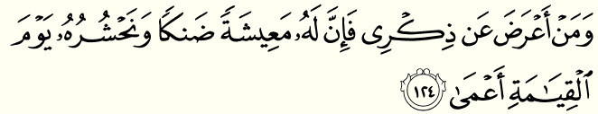
“But as for him who turns away from remembering Me – his shall be a life of narrow scope [depressed, sterile] and on the Day of Resurrection We shall raise him up blind”. Taha (20): 124
Every moment comes to an end. No one can ignore the transient nature of this world. The verse is drawing our attention to the fact that if we do not ascribe moments that we experience in this universe to its Absolute Conscious Creator, our existence feels meaningless which in turn does not befit our humanity at all. Our humanity desires to have a hopeful future.
For every moment that we gain in life, we lose another moment of existence and thus life gets near the end. As per the verse, we cannot get happiness without ascribing our existence to the Absolute Creator. We can only get happiness when we see that the end is actually an “opening”. It is in our nature to desire a happy Eternal life. He creates us with this desire so we may relate our expectations and hopes to Him only. This way of creation is a promise from Him that He is the One who takes care of our needs here and now. If we do not educate ourselves with directing our hopes and desires to Him, we feel miserable and depressed. The Speaker is telling us that we make ourselves blind when we are not happy with our Creator.
- If we remember God, our life will be wonderful. If we do not remember Him, it is at our own expense.
We all have the potentialities of acknowledging the Creator. If our potentialities have not been developed, we will remain ignorant. We are made in a way that we need to develop ourselves in the best possible way. Even the Prophets had to hone on their potentialities, they were not born with special skills. They got hopeless BUT worked on themselves.
We need to read the verse as far as “I am concerned”, not as far as “the Creator is concerned”. We need to understand the methodology of the scripture, from our perspective and not from the Creator’s perspective.
“But as for anyone who chooses to remain blind to the remembrance of the Most Gracious, to him We assign an evil impulse, to become his other self.” Zukhruf (43):36
- Evil Impulse= Satan= second nature=other self
When we are aware that everything is coming from an endless Source, we do not worry about not receiving Absolute Mercy because we are living it.
- Analogy: There is a dead end well with a river flowing underneath it. When we get water from the well, we are eventually aware that the water is not from the well but from another source. (Kauthar is a never ending river.)
- Similarly, we should not attribute the pleasure we experience from an object to the object itself but instead we need to attribute the pleasure to the actual Pleasure Giver. The object is like a dead end well but if we see an endless river flowing underneath, it becomes an Eternal Source of pleasure i.e. Kauthar.
The blessing of remembering God is that you are aware that only He can provide everything for you because you belong to Him. If you know who you are asking from, that is the acknowledgment of the Source. You know that He is the One who gives it to you.
- Prayer is not bargaining but acknowledgment.
Why are we given limitless desires? In order to acknowledge that the Source is Absolute and I can address to Him anything that I can imagine. These are the senses given by Him in order to communicate with Him through the senses. It is not bargaining as you are acknowledging that He is your Owner, your Lord. As a result, you do not bother about anything, death, illness… are given as a means to acknowledge that it is not you who is the Source of your own pleasure. It is your Creator that is the way of acknowledgment.
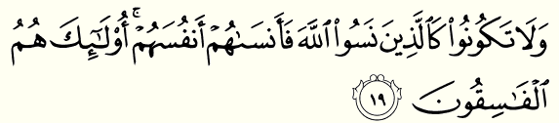
“And be not like those who are oblivious to God, and whom He therefore causes to be oblivious of their own selves: It is they, they who are truly depraved”. Hashr (59):19
- If we forget the Creator, we forget ourselves. The Creator reminds us of our reality that if we do not remember Him, we go against our humanity; as a result we get depressed. When a person forgets the Creator, there is no way for him to to communicate with the Absolute.

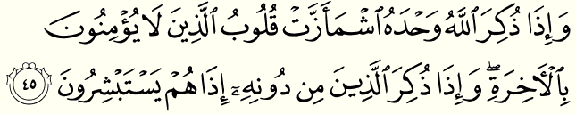
“And when God is mentioned alone, the hearts of the one who do not believe in the Hereafter shrink, and when the ones apart from Him are mentioned, only then immediately they rejoice.” Zumar (39):45
If someone does not believe in Eternity, He cannot experience Hereafter (Akhira).
- Akhira is the end of what we are experiencing right now.
Example: I am eating ice-cream.
There are two ways of experiencing Akhira to this event:
- The pleasure I am experiencing from this ice-cream happens to be by itself. Without acknowledgment, when the ice-cream is finished, my akhira of this thought is a complete distress.
- The pleasure I am experiencing is news from my Creator telling me that He is the One entertaining me. I acknowledge Him as the Merciful One.
Therefore, live your Akhira now. That is how we can connect ourselves to Eternity. In reality, if we are conscious, we are always experiencing the Akhira of our life. We are constantly being resurrected; the order of the universe demonstrates it: blood clotfetusbabyadult.
- Eternal life has to be experienced now in order to secure an Eternal existence.
For those who do not believe in God, they do not believe in the Hereafter because they are not open to receiving any guidance. However, when anything apart from death/reality is mentioned, they get sunk into deluded temporary happiness, which eventually leads to meaninglessness.
“So remember Me, and I shall remember you; and be grateful to me, and deny Me not.” Baqara (2):152
God is teaching us what our reality is: If we remember Him, then immediately we realize that God is with us. We will understand that He is always with us because He is our Creator. I will find Him in my own being because He is my Maker.
- If I remember God, I will find Him.
The Creator is letting us know to realize that everything is from Him. We should not turn blind or turn our back to Him.
- Always question the existence of everything i.e. why is it created this way?
- There is a message for us in everything from the Creator.
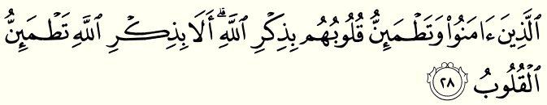
“Those who believe, and whose hearts find satisfaction in the remembrance of God: for without doubt in the remembrance of God do hearts find satisfaction.” Ra’d (13):28
When we remember God, our hearts will definitely find satisfaction. Remembrance must take place under the understanding from the interpretations of all the verses above. The hearts are created to be in need of satisfaction. They should get satisfied otherwise the creation of our senses would be in vain.
- Human hearts are created to remember God.
In conclusion, the only way to get Eternal satisfaction is through connecting our being to the Eternal One. Our senses are created with the capacity to get satisfaction from remembering God only.

